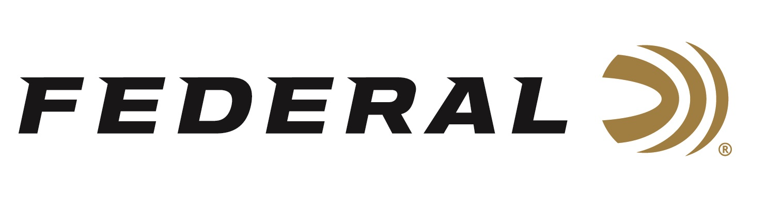

FOR IMMEDIATE RELEASE

Federal Ammunition Sponsored Trap Shooter Ashley Carroll
Strikes Gold at World Championship

ANOKA, Minnesota – July 18, 2019 – Federal Ammunition sponsored shooter Ashley Carroll wins her first ever International Shooting Sport Federation (ISSF) World Championship. The 24-year-old Californian edged her competitor from China in the finals to secure gold, her first world title in seven appearances at the championships held in Lonato, Italy. Her individual performance also propelled Team USA to the top of the podium in the women’s team match that also included another Federal pro staff member in Kayle Browning.

In winning the world title, Carroll becomes the first U.S. woman to earn a World Championship medal, along with the world title, since 1999. It’s the first Trap medal for Team USA at a World Championship, men or women, since 2006.

Federal Ammunition sponsored shooter Katie Jacob made her last year as a junior competitor count as she put fourth another fine showing at the 2019 World Championships, earning an individual silver medal and leading her team to a bronze medal in the process. No stranger to top-notch World Championship performances, it marks Jacob’s fourth straight top-seven finish and her third Finals appearance in four tries.

Serious shooters have long relied on Federal Gold Medal shotshells to dominate the competition in trap, skeet and sporting clay events worldwide. Year after year, Gold Medal rounds earn the respect of all levels of competitive shooters. The enhanced design of new Gold Medal Grand shotshells, introduced in 2017, builds on that tradition with less felt recoil, more reliable ignition, improved patterns, harder shot and maximum downrange power. The USA Shooting logo is also proudly displayed on boxes of Federal Gold Medal Grand.

Federal is the official shotshell ammunition sponsor and supplier of USA Shooting, a non-profit organization that promotes the shooting sports and prepares American athletes to bring home Olympic gold. Learn more about USA Shooting at: www.usashooting.org. For more information on Federal ammunition, visit www.federal.com.

Press Release Contact: JJ Reich
Senior Communications Manager - Firearms and Ammunition
E-mail: VistaPressroom@VistaOutdoor.com

About Federal Ammunition
Federal, headquartered in Anoka, MN, is a brand of Vista Outdoor Inc., an outdoor sports and recreation company. From humble beginnings nestled among the lakes and woods of Minnesota, Federal Ammunition has evolved into one of the world's largest producers of sporting ammunition. Beginning in 1922, founding president, Charles L. Horn, paved the way for our success. Today, Federal carries on Horn's vision for quality products and service with the next generation of outdoorsmen and women. We maintain our position as experts in the science of ammunition production. Every day we manufacture products to enhance our customers' shooting experience while partnering with the conservation organizations that protect and support our outdoor heritage. We offer thousands of options in our Federal and Federal® lines-it's what makes us the most complete ammunition company in the business and provides our customers with a choice no matter their pursuit.

